Exp No 9
Date:15/4/25
Objective
The objective of this implementation is to decompose a time series dataset into its key components: trend, seasonality, and residuals. This helps in understanding the underlying patterns in the data, which is crucial for forecasting and analysis.
Background & Scope
Time series decomposition is a fundamental technique used in time series analysis to separate data into:
- Trend: The long-term progression of the data.
- Seasonality: The repeated pattern at fixed intervals.
- Residuals: The random noise or irregular fluctuations in the data.
This technique is essential for fields such as economics, finance, weather forecasting, and energy consumption analysis.
Implementation Steps
Step 1: Import Required Libraries
We use libraries for data manipulation, visualization, preprocessing, and building the LSTM model.

import pandas as pd
import numpy as np
import matplotlib.pyplot as plt
import tensorflow as tf
from tensorflow.keras.models import Sequential
from tensorflow.keras.layers import LSTM, Dense
from sklearn.preprocessing import MinMaxScaler
from sklearn.model_selection import train_test_split

Step 2: Load Dataset
We read the CSV file and convert the DATE column to Datetime format.
# Load dataset
df = pd.read_csv("NFLX.csv") # Replace with your actual filename
# Convert DATE column to Datetime format
df[' DATE'] = pd.to_ Datetime(df[' DATE'], dayfirst=True)
df.set_index(' DATE', inplace=True)

Step 3: Normalize the Data
We scale the data to a range between 0 and 1 using MinMaxScaler.
# Normalize the data
scaler = MinMaxScaler()
df_scaled = scaler.fit_transform(df)

Step 4: Create Sequences for LSTM
We define a function to generate sequences of a fixed length to feed into the LSTM model.
# Create sequences for LSTM
def create_sequences(data, seq_length):
X, y = [], []
for i in range(len(data) - seq_length):
X.append(data[i:i+seq_length])
y.append(data[i+seq_length])
return np.array(X), np.array(y)

SEQ_LENGTH = 10 # Define sequence length
X, y = create_sequences(df_scaled, SEQ_LENGTH)

Step 5: Split Data into Training and Testing Sets
We split the dataset into 80% training and 20% testing without shuffling (since it's time-series data).
# Split into train and test sets
X_train, X_test, y_train, y_test = train_test_split(X, y, test_size=0.2, shuffle=False)
Step 6: Build the LSTM Model
We define a sequential LSTM model with two LSTM layers and one dense output layer.
# Build LSTM Model
model = Sequential([
LSTM(50, activation='relu', return_sequences=True, input_shape=(SEQ_LENGTH, 1)),
LSTM(50, activation='relu'),
Dense(1)
])

Step 7: Compile and Train the Model
We compile the model using Adam optimizer and mean squared error as the loss. Training is done for 5 epochs.
model.compile(optimizer='adam', loss='mse')
model.fit(X_train, y_train, epochs=5, batch_size=16, validation_data=(X_test, y_test)) # Changed epochs to 5

Step 8: Make Predictions
# Make predictions
y_pred = model.predict(X_test)
y_pred_rescaled = scaler.inverse_transform(y_pred)

Step 9: Visualize the Results
We plot the actual vs. predicted values for comparison.
# Visualize results
plt.figure(figsize=(10,5))
plt.plot(df.index[-len(y_test):], scaler.inverse_transform(y_test.reshape(-1,1)), label="Actual")
plt.plot(df.index[-len(y_test):], y_pred_rescaled, label="Predicted", linestyle="dashed")
plt.legend()
plt.title("LSTM Time Series Forecasting (5 Epochs)")
plt.show()
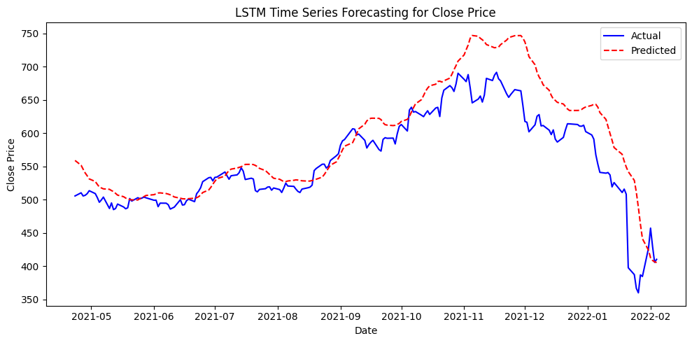

Conclusion
This implementation successfully decomposes a time series dataset into its core components. The results help in identifying patterns such as long-term trends and seasonal variations, which are critical for making data-driven decisions in various domains. By analyzing the residuals, we can also assess how well the model captures the data's structure and identify any anomalies or outliers.

